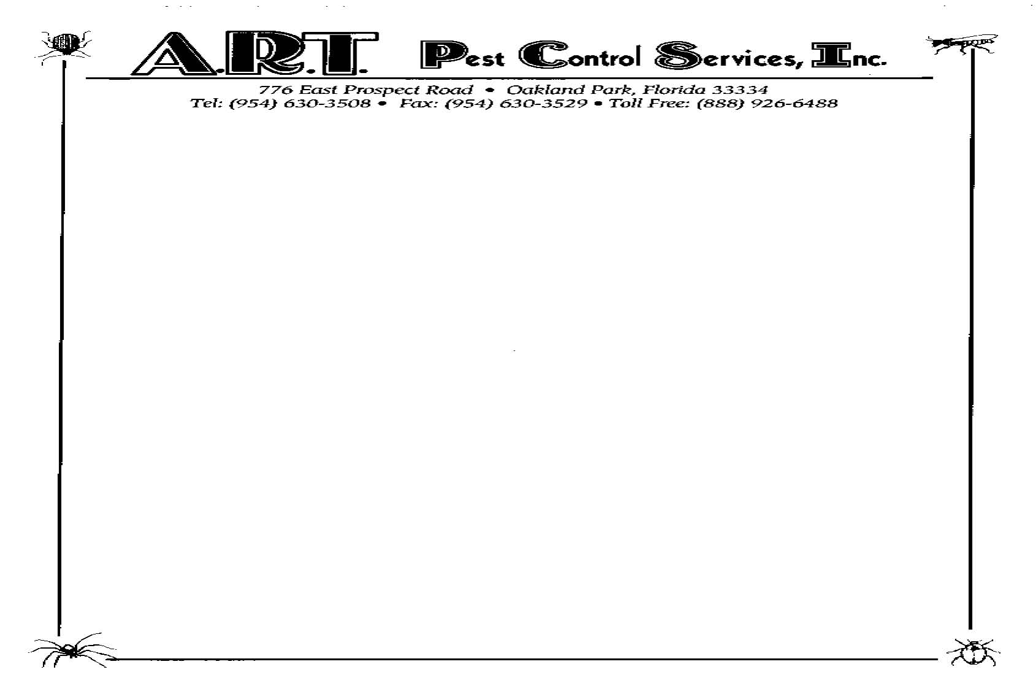

To: Resident
Re: Flea Treatment Preparation

In order for the flea treatment to be effective, the following instructions should be followed:

Preparation:
• Vacuum carpeted areas and dispose of bag.
• Remove pets, pet food and litter box.
• Remove any pet bedding and wash.
• Sweep and mop all non-carpeted areas.
• Remove items from floors and make sure the areas under beds are accessible.
• Aquariums must be turned off and covered.
• Air conditioners should be turned off.

Allow a minimum of two (2) to four (4) hours after treatment before reentering unit. Chemical must be dry.

PETS MUST BE TREATED THE SAME DAY THAT WE ARE IN YOUR UNIT.

Post Treatment:
• Vacuum carpets again and dispose of bag. Repeat every two to three days.

Allow 7-10 days for results. A second treatment will be performed after 7-10 days.

Failure to follow these preparation procedures may limit or negate the effects of treatment.

When treating for fleas, we use a combination of two chemicals. The first is an adulticide, which kills the adult fleas. The other is an Insect Growth Regulator (IGR). The IGR prevents young fleas from maturing to adults. Only adult fleas jump on people and pets, and only adults reproduce. Setting off foggers to control fleas is not a complete treatment. Foggers only kill adult fleas. They do not leave any residual behind to control hatching eggs. Under normal circumstances, it takes about 10 days for a normal infestation to be controlled, not deleted. The unit, if not prepared correctly or vacuumed thoroughly four hours after treatment, may require a second treatment.

If you have any questions regarding these procedures, please contact the Leasing Office or call our office at (954) 630-3508.

Thank you,
A.R.T. Pest Control Services, Inc.

