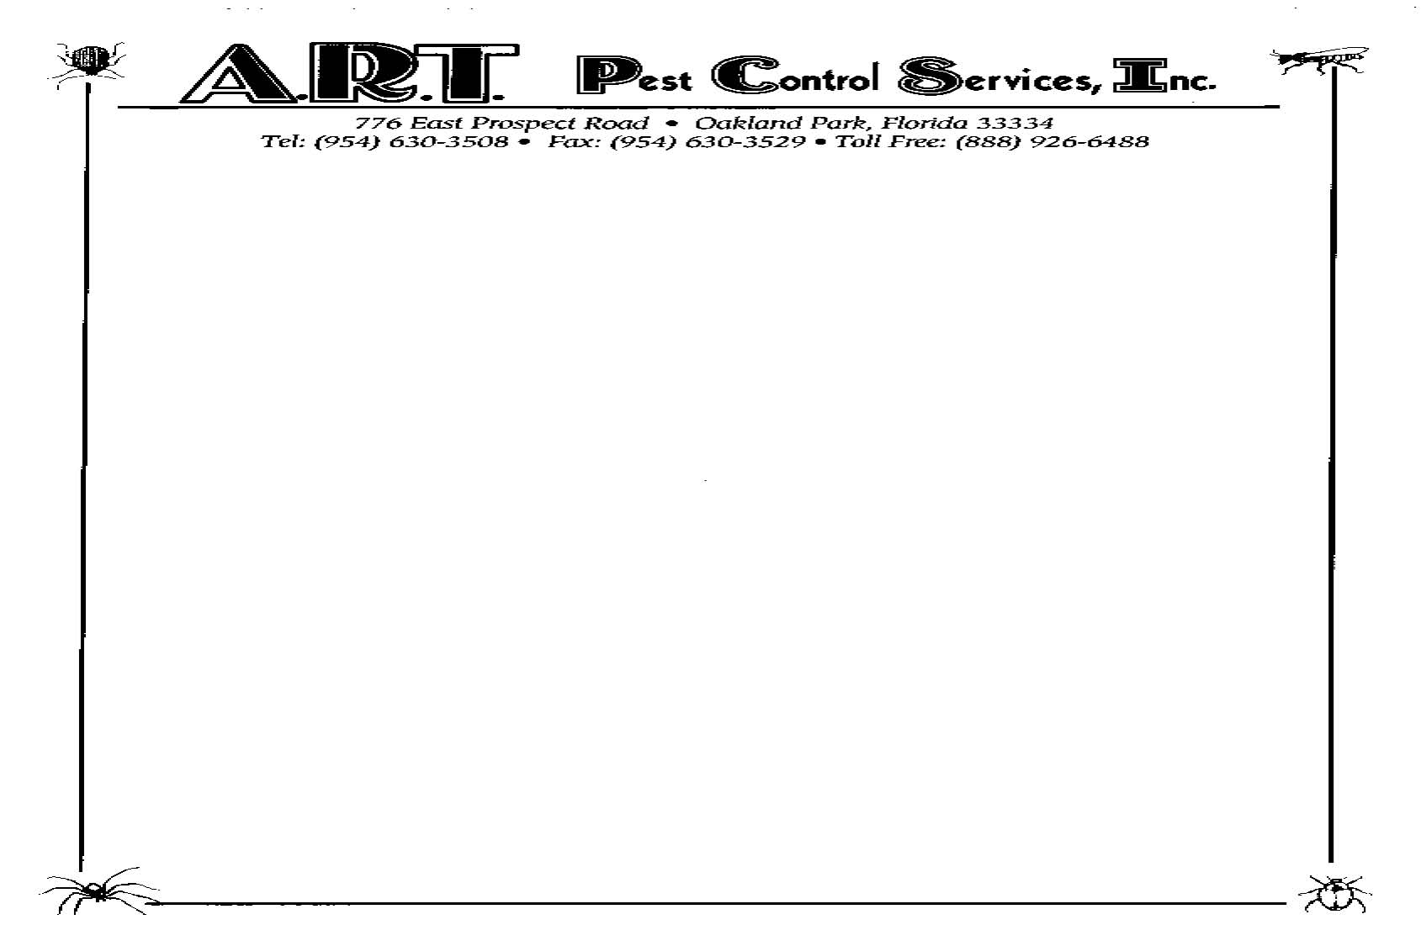

To: Resident
Re: Cockroach Treatment Preparation

Dear Customer:

In order to achieve successful results in eliminating the roach problem at your unit, please follow these instructions prior to treatment:

- Empty all cabinets and counters.
- Make sure no roaches have been moved with kitchen items to the temporary storage area.

These measures will allow the pest control technician to access all hiding and nesting areas in the kitchen.

We recommend the resident vacate the unit for at least three hours after the treatment, as the odor and fumes of the insecticides may be offensive. After the application is dry, the resident can resume normal activities in the treated areas.

In order to facilitate the monitoring and control of cockroaches, the conditions that are attractive and favorable to roaches must be eliminated. Cockroaches are nocturnal, and prefer to hide in dark, warm places. Sanitation and good housekeeping measures are paramount in controlling roaches.

These are our recommendations to keep your residence free of German roaches:

- Eliminate sources of food and water wherever possible.
- Store food in sealed containers.
- Place garbage and trash in containers with tight fitting lids.
- Remove trash, paper, boxes and other items that may provide hiding places.
- Check plumbing and other areas for leaks or moisture buildup.
- Clean food and beverage spills as quickly as possible.
- Remove grease from cooking areas, fans, counters and floors.

Although these precautions sound elementary, they are essential to properly monitor and control the any roach problem.

Thank you for your cooperation.

A.R.T. Pest Control Services, Inc.

